**Linux Basic Commands Assignment**

***Assignment Part-3***

Playing with files

1. Create a file like **nano file1.txt**

o Edit some data and then save the file

**Ans:**

Create a file : touch file1.txt

Edit file : vi file1.txt

Save and quit : esc:wq!

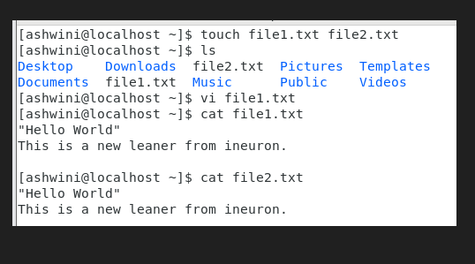

2. Now we will copy date from file1 to new file2

**o cp file1.txt file2.txt**

o Then see the output of file2.txt, **cat file2.txt**

o Give screenshot

**Ans:**

Create file2 : touch file2.txt

Copy data from file1 to file2 : cp file1.txt file2.txt

Output of file2.txt : cat file2.txt

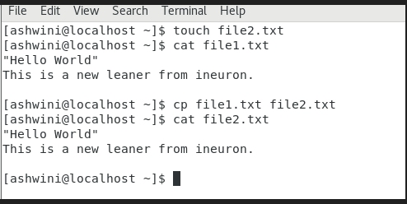

3. Now we will move the file2.txt to new folder **/home**

o **mv file2.txt /home**

o Then go to **home** directory and check **ls,** file exits or not?

o Given screenshot

**Ans**:

Move file to /home : sudo mv file2.txt /home

Go to /home : cd /home

To Check :ls

File2.txt exists.

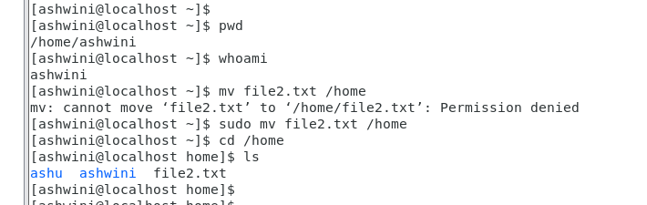

4. Then we create a new **file3.txt and file4.txt** in **home directory** and add

content in it.

o Now do **echo** **“Hello I am newline” > file3.txt** and provide the

output of file3.txt

o Now do **echo “Hello I am newline” >> file4.txt** and provide the

output of file4.txt

o Tell the different between both step you follow and the reason

behind it

**Ans:**

Create new file3.txt and file4.txt : touch file3.txt file4.txt

Add content in file3.txt : echo “Hello World I am a new learner”

And again add content in file3.txt : echo “Hello I am newline” > file3.txt

Output of “>”:

**Hello I am newline**

Add content in file4.txt : echo “Hello World I am a new learner”

Again add Content to file4.txt: echo “Hello I am newline” >> file4.txt

Output of “>>”:

**Hello World I am a new learner”**

**Hello I am newline**

Diffence between “>” and “>>” used - the “>” is the output redirection operator used for overwriting files that already exist in the directory.

While, the “>>” is an output operator as well, but, it appends the data of an existing file.

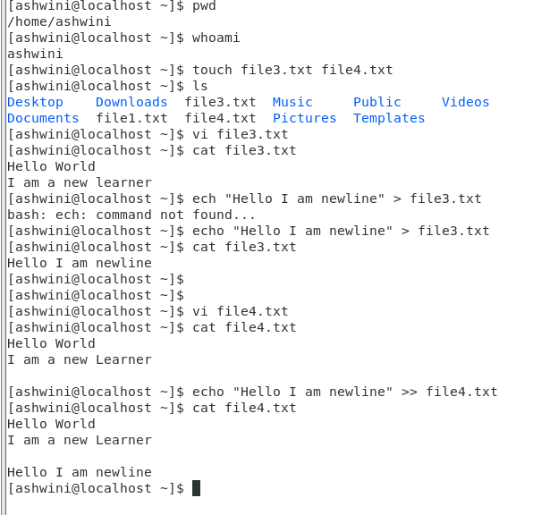

5. For remove a file or directory you can use the below two commands

**o** To delete a file – **rm <any_filename>**

**o** To delete a directory - **rmdir <any_directoryname>**

**Ans:**

Remove file: rm file1.txt

Remove directory: rmdir ash

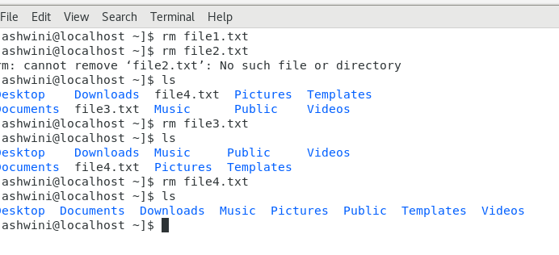

<file1.txt> <file3.txt> <file4.txt> deleted

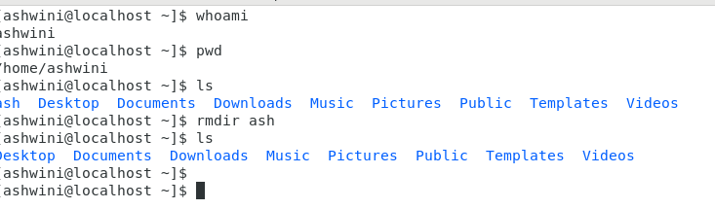

<ash> dir deleted

=====================================================================================